Testing web application

**DEADLINE:** 06/04/2020

## DESCRIPTION

There’s an application to check whether Credit Card is valid or not.

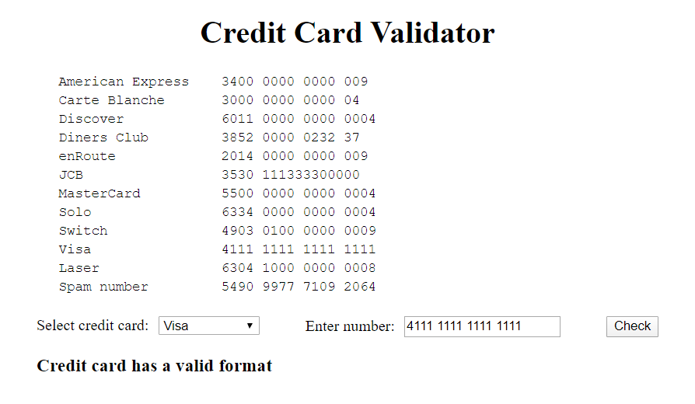

## TASK

One function named **testCreditCard** is responsible for all validation logic. It is part of public API of **CreditCardService**. In purpose to have well maintained and extensible code you should cover it by unit tests.

## HINTS

* No need to test private methods
* Write tests for **testCreditCard** method only
* Try to cover most vulnerable places of code

Commands to run tests:

* Unit tests: *ng test*
* Unit tests with code coverage: *ng test –code-coverage*
* e2e test: *ng e2e*

## BEFORE SUBMIT

* Remove all unnecessary files that you might have included by mistake
* Verify that all functionality is implemented according to requirements
* Add comments if the code is difficult to understand
* Fix warnings/errors in the browser console
* Make sure there are no errors/warnings in the browser console
* Run the linter and fix all warnings and errors

## SUBMIT

* The folder should be uploaded to your GitHub repository into master branch

## USEFUL LINKS (and books)

* <https://jasmine.github.io/>

*Use links from presentation as well*